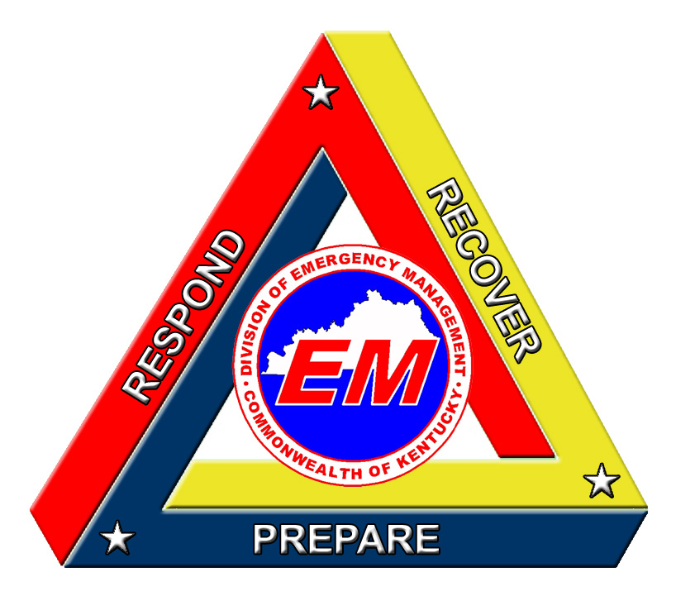
Public Service Announcement
Neighbor Helping Neighbor Insert Photo Here
Provided by your
Local Emergency Management Office

NEIGHBOR HELPING NEIGHBOR

If someone you know is elderly or dependent on life-sustaining or health-related equipment such as a ventilator, respirator or oxygen concentrator, you should make plans now to ensure their needs are met during severe winter weather and possible power outages.

1. Help them stock a home disaster kit including a flashlight and extra batteries, a battery-operated radio, bottled water, non-perishable foods, essential medicines, and extra blankets or sleeping bags.

2. Check on them after a storm or power outage. Register them, as a special needs customer with their utility so they will become a priority customer. Notify others who could provide help such as neighbors, relatives, nearby friends and local emergency responders such as the fire department.

3. Have a list of emergency numbers readily available.

4. Have a standby generator or an alternative source of power available. Be aware of the safety rules for its use.

